**NEWSLETTER** 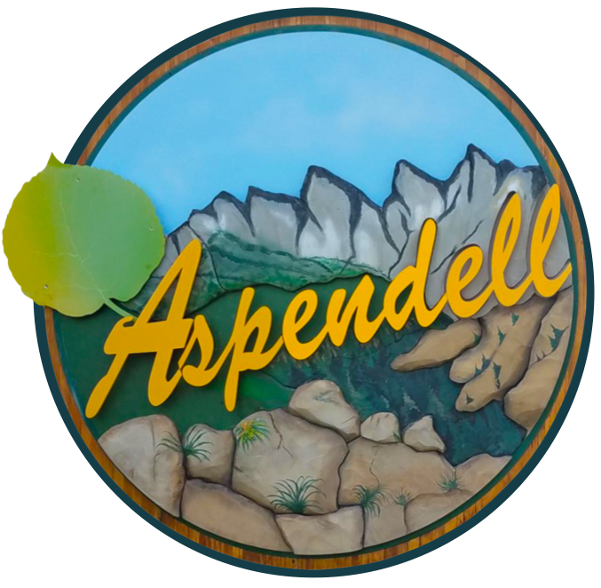

***ALPINE WATER COMPANY***

July 9, 2022

Dear Members of the Alpine Water Company,  
  
Our annual board meeting happened on July 2nd. If you came, thanks! Those in attendance along with the mailed in proxies added up to 31 out of 46 Tract 2 lots being represented. There was much discussion about the age of our water system initially installed in 1978 (~ 44 years old), the repairs already completed in the last 2 years (e.g., relining of the reservoir, replacement of one of the well pumps, etc. costing ~ $70,000), and the recently discovered failures (mainline leaks/repairs) and overall degradation of the system.   
  
In last year’s meeting, the contingent approved an increase in our annual rates with an expectation that over approximately 3-5 years our bank assets would recover to our pre-2020 levels, this in lieu of a one-time assessment. But it has become clear that this approach will be inadequate for the foreseeable future requirements.

California state guidelines tell us that a water company of our size should have approximately $200,000 in the bank. At the moment we have less than 1/4th of that sum. If our system suffers a catastrophic failure, we can't afford to fix it. This, along with the status of our system, and the model being implemented by our neighboring water companies, has forced us to re-evaluate a one-time assessment. The relatively cheap rates we have enjoyed in all these past years has now caught up to the company as a whole.

To accommodate this issue, it was proposed in the meeting that the Water Company implement a one-time assessment for each lot in Tract 2 which parallels a typical assessment adopted by Tracts 1 & 3. This would be in the amount of $5,000 initiating in January 2023. Each developed lot would have an allotted 2-year period to pay down the assessment, while an undeveloped lot would have an allotted 4-year period. In addition, there would be a 10% discount for any payments made in the first 6-month billing period in 2023, and a 5% discount made in the second 6-month billing period of 2023. Please review the minutes for exact verbiage. A motion was made to implement this assessment and the attendance unanimously approved.

Obviously, this was a difficult decision and one we do not take lightly. As reiterated in last year’s newsletter – “One thing is clear: Our property values in Aspendell hinge on access to plentiful water. Water is critical to everything from daily living to emergency firefighting. Imagine trying to refinance or sell your home, to qualify for a construction loan, or to buy homeowners insurance in a community with no reliable water supply. We simply can't take chances…”  
  
Sincerely,  
  
The Water Board

Jerry Billings – [jabkap@hotmail.com](mailto:jabkap@hotmail.com) Tony Phillips – [dr.tony.phillips@gmail.com](mailto:dr.tony.phillips@gmail.com)

Bill Stever – [egoldies39@gmail.com](mailto:egoldies39@gmail.com) Brian Nix – [nix.briant@gmail.com](mailto:nix.briant@gmail.com)