**NEWSLETTER** 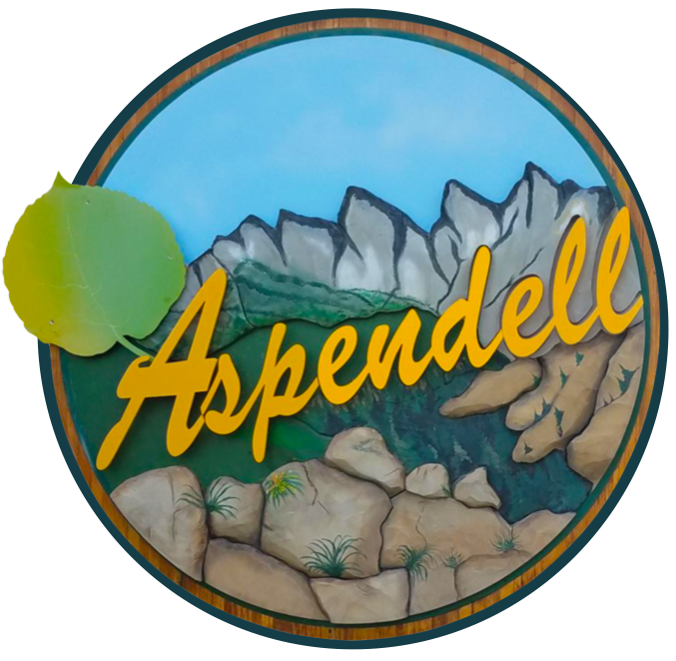

***ALPINE WATER COMPANY***

August 23, 2021

Dear Members of the Alpine Water Company,  
  
Our annual board meeting happened on July 17th. If you came, thanks! There was much discussion about recent improvements to our water system. In 2020 we spent almost $70,000--mainly re-lining our reservoir with an advanced material that should last for the next 50 years. We also replaced a malfunctioning pump along with other minor improvements and repairs.  
  
Now we have to bounce back from these big expenditures. Our reserves are now at an all-time low, only $30,000, which leaves us poorly prepared to deal with any sudden emergency. To re-build our savings, the Board and attending members voted unanimously to raise our rates.

One option we contemplated was a big, one-time assessment, which would rapidly re-fill our coffers. Instead, we decided on a more gradual approach, described below:

Starting in January 2022, annual fees will increase to $500 for developed lots and $400 for undeveloped lots. To soften the blow of this increase, the bill with be divided in two 6-month due dates. Half may be paid in January, and the balance in June. This increase will allow us to re-build our savings to pre-2020 levels (~$90,000) within 5 years.

Although everyone voted unanimously in favor of the increase, some attendees of the meeting worried that homeowners would question the increase. Others noted that $500/year is less than what urban homeowners typically pay for water far inferior to Aspendell's.  One thing is clear: Our property values in Aspendell hinge on access to plentiful water. Water is critical to everything from daily living to emergency firefighting. Imagine trying to refinance or sell your home, to qualify for a construction loan, or to buy homeowners insurance in a community with no reliable water supply. We simply can't take chances; raising rates to these reasonable levels is the only responsible thing to do.  
  
We are tentatively planning a Zoom meeting in December to test our ability to assemble remotely. Details will follow, and we hope to see you then!  
  
Sincerely,  
  
The Water Board

Jerry Billings – [jabkap@hotmail.com](mailto:jabkap@hotmail.com)

Tony Phillips – [dr.tony.phillips@gmail.com](mailto:dr.tony.phillips@gmail.com)

Bill Stever – [egoldies39@gmail.com](mailto:egoldies39@gmail.com)